18) Write a C program to accept a line of text from the user and convert each lower case

letter to upper case and vice-versa.

#include<stdio.h>

#include<string.h>

int main()

{

int i,n=0;

char ch[20];

printf("Enter a word or a sentence\n");

gets(ch);

n=strlen(ch);

for(i=0;i<n;i++)

{

if(ch[i]>=65 && ch[i]<=90)

{

ch[i]=ch[i]+32;

}

else if(ch[i]>=97 && ch[i]<=122)

{

ch[i]=ch[i]-32;

}

}

printf("%s",ch);

}

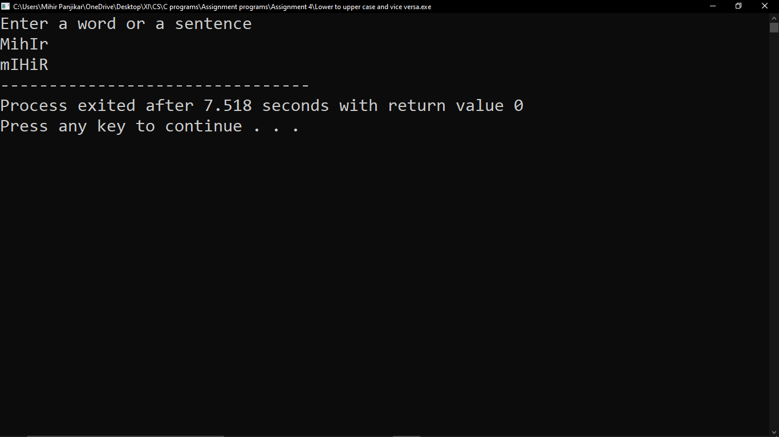

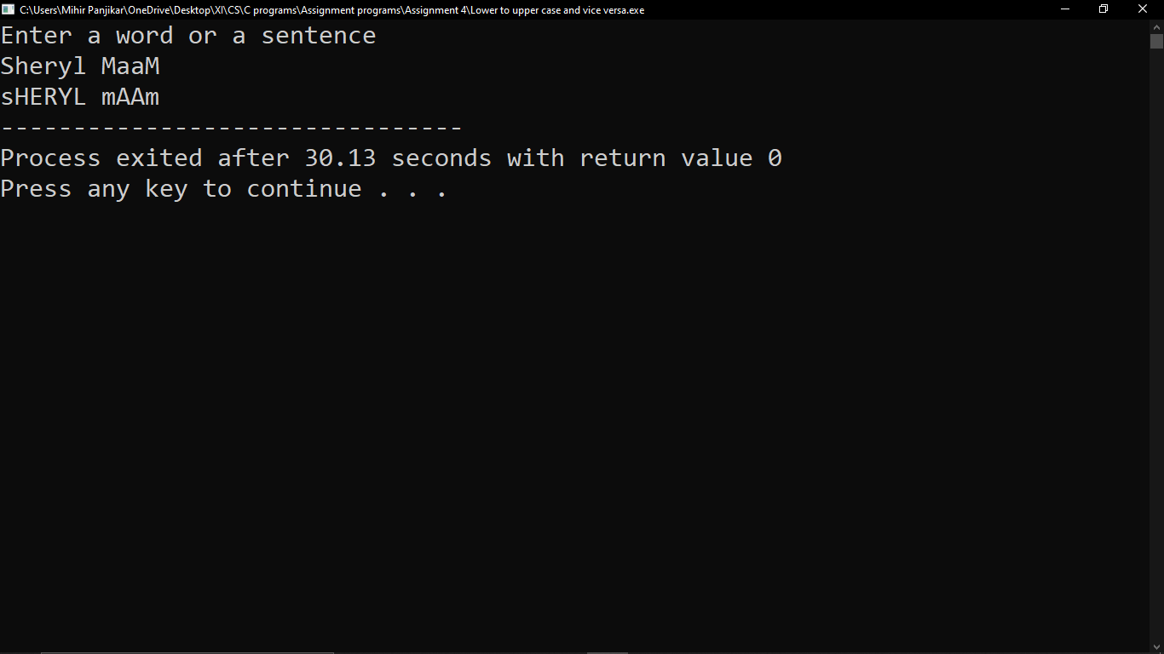

19) Write a program to accept a line of text from the user and count the number of words

#include<stdio.h>

#include<string.h>

int main()

{

char words[25];

int n,i,wc=0;

printf("Enter a sentence\n");

gets(words);

n=strlen(words);

for(i=0;i<n;i++)

{

if(words[i]==32)

{

wc++;

}

}

wc++;

printf("%d",wc);

}

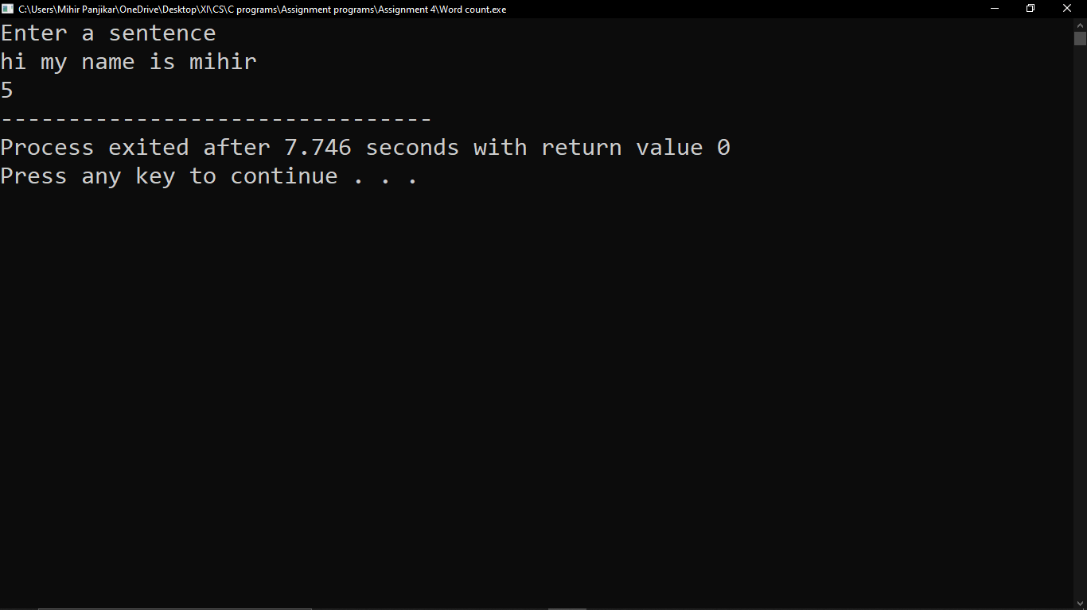

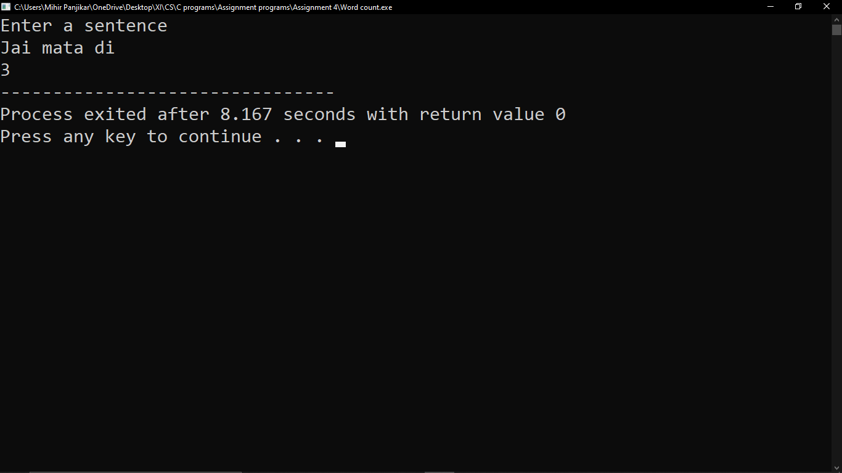

20) Write a C program to determine if the given word is a palindrome or not.

#include<stdio.h>

#include<string.h>

int main()

{

int n,i,k;

char ch[10];

printf("Enter a word\n");

gets(ch);

n=strlen(ch);

i=0;

k=n-1;

while (k > i)

{

if (ch[i++] != ch[k--])

{

printf("%s is Not a Palindrome", ch);

return 0;

}

}

printf("%s is a palindrome", ch);

}

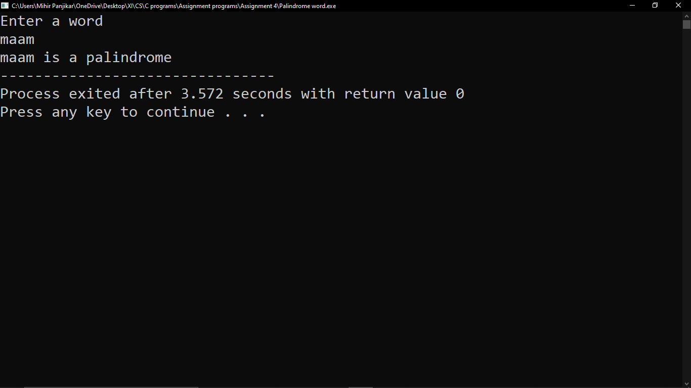

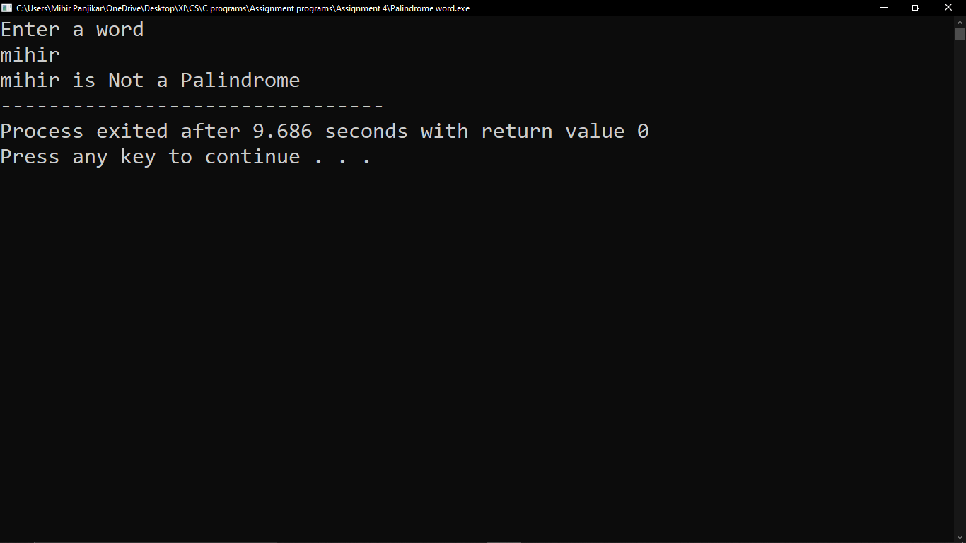

21) Write a C program to implement strcat function.

#include<stdio.h>

#include<string.h>

int main()

{

char arr2[20];

char arr1[20]="Hello ";

printf("Enter your name\n");

scanf("%s",&arr2);

strcat(arr1,arr2);

printf("%s",arr1);

}

